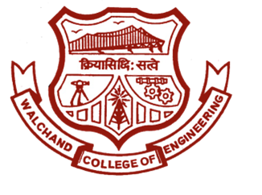

WALCHAND COLLEGE OF ENGINEERING, SANGLI
(AN AUTONOMOUS INSTITUTE)

DEPARTMENT OF ELECTRONICS ENGINEERING
ELESA
ELectronics Engineering Students Association

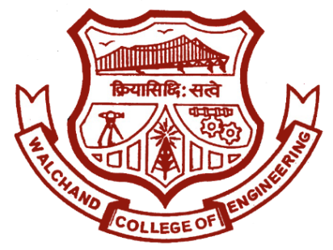
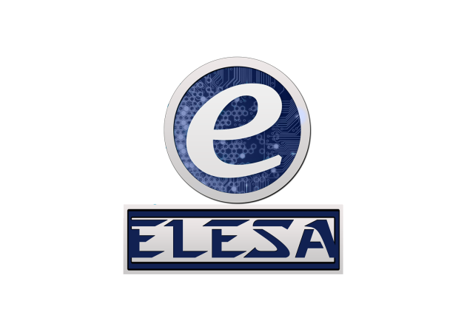
Walchand College of Engineering, Sangli.
(An autonomous institute)

ELESA
Electronics Engineering Students’ Association

Email: walchand.elesa@gmail.com Website: www.elesa.in

To,
Dr. B. G. Patil,
Dean Students Welfare,
Walchand College of Engineering,
Sangli.

SUBJECT: Proposal for activities of ELESA in academic year 2017-18.

Respected Sir,
ELESA (Electronics Engineering Students Association) is a technical club of Electronics Department, Walchand College of Engineering, Sangli. ELESA works for development and growth of students especially in Electronics Engineering. This is proposal for the activities to be conducted by ELESA in the academic year 2017-18. All the contents in the proposal is legitimate and true to best of my knowledge. We urge you to grant permission for conducting the events mentioned in this proposal.
Yours sincerely,

Approved By,

Mr. Shubham Mhatre
President, ELESA
Dr. S. D. Ruikar
Staff Advisor, ELESA
Dr. B. G. Patil
H.O.D., Dept. of Electronics

Dr. B.G. Patil
Dean Students Welfare,
WCE Sangli.

Dr. G. V. Parishwad,
Director,
WCE Sangli.

ELESA TEAM

NAME | POST
Dr. B. G. Patil | HOD, Electronics
Dr. S. D. Ruikar | Staff Advisor
Mr. Shubham Mhatre | President
Miss Pooja Arekar | Vice President
Mr. Amit Patil | Event Director
Mr. Raunak Suryawanshi | Event Director
Miss Sunita Patil | Technical Director
Mr. Raghunandan Kangule | Technical Director
Mr. Shantanu Vipradas | Aptitude Developer
Miss Arati Balekundri | Aptitude Developer
Miss Swaroopa Ingle | Club Service Director
Mr. Rushikant Birajdar | Website Developer
Mr. Prafull Mahajan | Website Developer
Mr. Hrishikesh Nikam | Treasurer
Miss Revati Shiudkar | Digital Publicity Head
Mr. Shivam Aware | Digital Publicity Head

About ELESA

Electronics Engineering Students Association is a departmental; technical club of Walchand College of Engineering, Sangli. Which was established in the year 1992 has a trademark feature of reinventing itself every time, year after year. The ELESA represents current students within the Electronics Engineering Dept. at WCE, Sangli. Our goal is to organize social and professional activities which strengthen and enrich the community within the department, and to help publicize various research activities within the department. We organize social events and help to communicate with the department and the students. Here, the students organize themselves to develop and improve various skills and to impart technical knowledge and keep in pace with the latest trends in technology by arranging club services.

EVENTS

- ELESA AWARDS: ELESA AWRDS is new initiative undertaken this year. This is to felicitate the students who perform extra-ordinary in the academic year for ELESA.
- Summer Special Events: ELESA this year initiated a new activity “Summer Special Awards”. This activity is conducted in month of June for students in Electronics Engineering. The activity consists of technical as well as non-technical events.
- Departmental Visit: Every year ELESA organise Departmental visit for newly admitted students in Electronics Engineering. This activity helps them know about the Department of Electronics.
- General Interest Meet: GIM is conducted by ELESA every year for First Year students. This activity helps them make familiar with ELESA family. They also learn some of the recent technologies which are not included in academics.
- Teachers Day Celebration: ELESA celebrates Teachers day on 5th Sept to felicitate and show respect to the work of all faculties in the Department.
- ELECTROVERT: ELESA every year organise a state level mega event. This event is completely organised by the board members of ELESA. This event helps ELESA get a global identity. This 2-day event consist of technical events, management events, quizzes, etc. This event has very good response every year.
- Industrial Visit: This year ELESA is planning to arrange an IV to nearby industries to get industrial exposure.
- Alumni Meet: ELESA organise an interactive session with the Alumni. Alumni share their experience with the students and also guide them for their carrier.
- Workshops: ELESA conducts various workshops like Proteus workshop for First Year students, HTML, PHP, CSS workshops.
- Intra Club Activity: We arrange intra club activity for overall development of students. Intra Club Activity helps students acquire some special skillsets which include technical, management and soft skills along with team work.
- Excellence (Mock Campus Event): Every Year ELESA organise a Mock Campus Event for board members to make them understand the recruitment process.
- Weekly Club Services: Weekly Club Services include technical sessions, aptitude sessions, group building activities, etc. Club Service results in overall development of each individual.
- Social Activities: We also organise various social activities to contribute to the society we live in.

 | ELECTROVERT 2016
 | Event Expenditure
 |  |  | Proteus | 8051 | Circuit | FE Special | Project Presentation | Paper presentation | Management |  | Quiz |  | Electro-Champ |  |  |  |  |  | Total
 | Cost per head | Team members per team | 2 | 2 | 2 | 1 | 4 | 2 | 2 |  | 2 |  | 2
 |  | Registered Team | 34 | 61 | 149 | 89 | 13 | 123 | 35 |  | 136 |  | 6
 |  | Income through event | 2720 | 4880 | 11920 | 4450 | 2600 | 9840 | 7000 |  | 6800 |  | 800 |  |  |  |  |  | 51010
 | 7 | Certificates | 476 | 854 | 2086 | 623 | 364 | 1722 | 490 |  | 1904 |  | 168 |  |  |  |  |  | 8687
 | 12 | Refreshment | 480 | 840 | 1800 | 480 | 624 | 1248 | 840 |  | 0 |  | 288 |  |  |  |  |  | 6600
 | 80 | Trophy | 280 | 280 | 560 | 140 | 320 | 280 | 160 |  | 280 |  | 320 |  |  |  |  |  | 2620
 |  | Prize | 2500 | 2500 | 5000 | 2500 | 2000 | 2500 | 2000 |  | 2500 |  | 2000 |  |  |  |  |  | 23500
 | 6 | Notepad and Pen | 204 | 366 | 894 | 534 | 78 | 0 | 210 |  | 816 |  | 72 |  |  |  |  |  | 3174
 |  | Total Event wise | 3940 | 4840 | 10340 | 4277 | 3386 | 5750 | 3700 |  | 5500 |  | 2848 |  |  |  |  |  | 44581
 | Other Expenditure |  | Print | Inauguration | Components | Decoration | Poster | Banner |  | Remuneration |  | Receipt |  | Total
 |  |  | 2900 | 379 | 505 | 500 | 3600 | 600 |  | 1300 |  | 1100 |  | 10884
 |  | Other Expenditure | Total expenditure for event |  | Total expenditure |  | Income through event | Sponsorship | Total Income |  | Funds
 |  | 10884 | 44581 |  | 55465 |  | 51010 | 8000 | 59010 |  | 20,388

EVENTS SCHEDULE
EVENT | DATE | Tentative Budget
ELESA AWARDS | Annual Event | 2,000
Summer Special Events | 1 June – 20 June 2017 | 500
Departmental Visit | 2nd August 2017 | 250
General Interest Meet | 7th August 2017 | 400
Teachers’ Day Celebration | 5th Sept 2017 | 2,500
ELECTROVERT 2k17 | 9th and 10th Sept 2017 | 50,000
Alumni Meet | Weekend of Jan 2018 | 1,500
Industrial Visit | Oct. 2017 or Feb 2018 | 1,500
Workshops | Weekends | N.A.
Intra Club | Dec 2017 to Jan 2018 | 4,000
Excellence | March 2018 | 2,500
Weekly Club Services | Every Monday | 150 each
Social Activities | As required | 500

